
Programming 2B (PROG6212)
Part 1

Otlotleng Mabiletsa ST10478180

Contents
Section A — ERD 2
Section B — API Endpoint Plan 5
Section C — SQL Database Script 8
Section D — GitHub, CI/CD and Submission Evidence 17
. GitHub Commit Evidence 19
References 20

Section A — ERD
Entity | Description
Users | Stores each user account and links the user to a role such as Organiser or Participant.
Roles | Lookup table for the two system roles: Organiser and Participant.
Events | Stores event information including name, description, date, location, distance and event type.
Categories | Stores age-based or distance-based categories used for event participation.
EventCategories | Junction table connecting Events and Categories in a many-to-many relationship.
Enrolments | Records Participants entering Events and selecting a Category.
Results | Stores a Participant result after an event, including finish time and finishing position.

ERD Screenshot
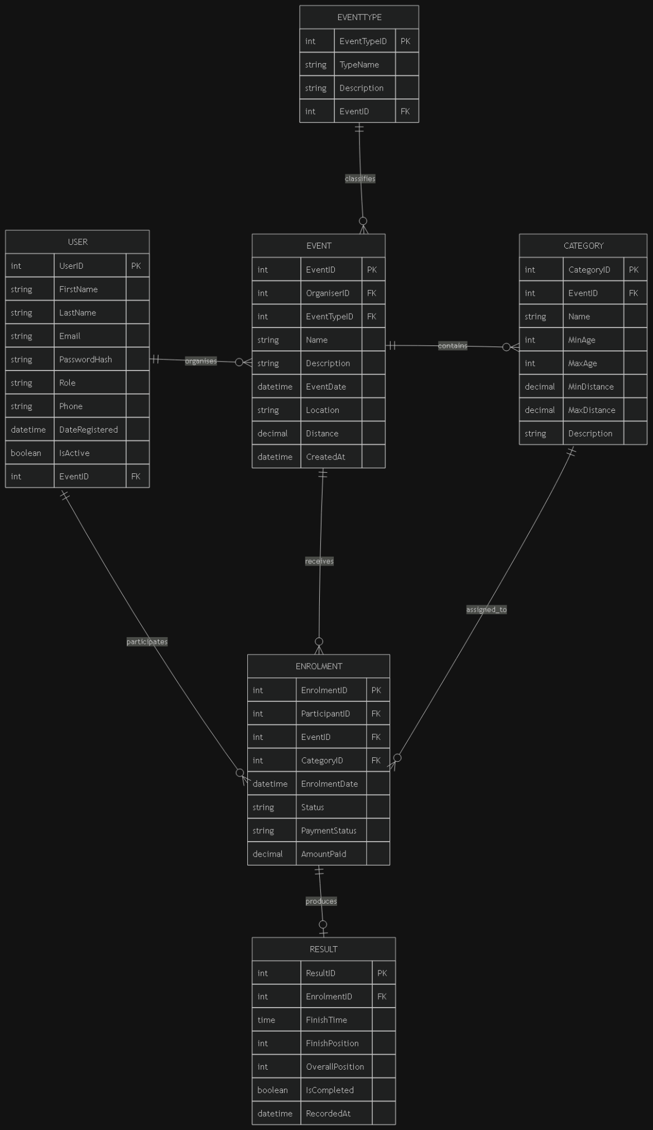
Relationship and Cardinality
Relationship | Cardinality | Explanation
Users → Roles | Many-to-One | Each user has one role; one role can belong to many users.
Roles → Users | One-to-Many | A role can be assigned to many user accounts.
Users → Enrolments | One-to-Many | A Participant can have many enrolments; each enrolment belongs to one participant.
Users → Events | One-to-Many | An Organiser can create many events; each event belongs to one Organiser.
Events → Enrolments | One-to-Many | One event can have many enrolments; each enrolment belongs to one event.
Events → EventCategories | One-to-Many | One event can be linked to many categories through EventCategories.
Categories → EventCategories | One-to-Many | One category can be linked to many events through EventCategories.
Enrolments → Results | One-to-One | Each enrolment can have zero or one result; each result belongs to one enrolment.
Enrolments → Categories | Many-to-One | Each enrolment selects one category; a category may be used by many enrolments.

. Primary and Foreign Keys

Entity | Primary Key | Foreign Key(s)
Users | UserId | RoleId → Roles.RoleId
Roles | RoleId | —
Events | EventId | OrganiserId → Users.UserId
Categories | CategoryId | —
EventCategories | EventCategoryId | EventId → Events.EventId; CategoryId → Categories.CategoryId
Enrolments | EnrolmentId | ParticipantId → Users.UserId; EventId → Events.EventId; CategoryId → Categories.CategoryId
Results | ResultId | EnrolmentId → Enrolments.EnrolmentId

Section B — API Endpoint Plan

HTTP Method | Route | Description | Role Required | Request Body | Expected Response
POST | /api/auth/register | Register a new user account with role selection (Organiser or Participant). | None (Public) | { email, password, firstName, lastName, role } | 201 Created — userId, email, role; 400 Bad Request — validation error; 409 Conflict — email exists
POST | /api/auth/login | Authenticate a user and establish a session. | None (Public) | { email, password } | 200 OK — userId, email, role, firstName, lastName; 401 Unauthorized — invalid credentials
GET | /api/users/profile | Get the currently authenticated user profile. | Any (Logged in) | None | 200 OK — user profile; 401 Unauthorized — not authenticated
PUT | /api/users/profile | Update the authenticated user profile. | Any (Logged in) | { firstName, lastName, email } | 200 OK — updated profile; 400 Bad Request — validation error; 401 Unauthorized
POST | /api/users/profile/picture | Upload a profile picture for the authenticated user. | Any (Logged in) | Multipart form data: { profilePicture } | 200 OK — profilePictureUrl; 400 Bad Request — invalid file; 401 Unauthorized
GET | /api/events | Get all events with optional filters. | Any (Logged in) | None; query params: type, dateFrom, dateTo | 200 OK — array of events; 401 Unauthorized
GET | /api/events/{id} | Get a specific event by ID including categories. | Any (Logged in) | None | 200 OK — event object; 404 Not Found; 401 Unauthorized
POST | /api/events | Create a new event. | Organiser | { name, description, eventDate, location, distance, eventType, bannerImage? } | 201 Created; 400 Bad Request; 401 Unauthorized; 403 Forbidden
PUT | /api/events/{id} | Update an existing event. | Organiser | { name, description, eventDate, location, distance, eventType, bannerImage? } | 200 OK; 400 Bad Request; 401 Unauthorized; 403 Forbidden — not owner; 404 Not Found
DELETE | /api/events/{id} | Delete an event. | Organiser | None | 204 No Content; 401 Unauthorized; 403 Forbidden — not owner; 404 Not Found
POST | /api/events/{id}/banner | Upload an event banner image. | Organiser | Multipart form data: { bannerImage } | 200 OK — bannerImageUrl; 400 Bad Request; 401 Unauthorized; 403 Forbidden
GET | /api/categories | Get all categories. | Any (Logged in) | None | 200 OK — array of categories; 401 Unauthorized
GET | /api/categories/{id} | Get a specific category by ID. | Any (Logged in) | None | 200 OK — category; 404 Not Found; 401 Unauthorized
POST | /api/categories | Create a new category. | Organiser | { name, description, categoryType } | 201 Created; 400 Bad Request; 401 Unauthorized; 403 Forbidden
PUT | /api/categories/{id} | Update an existing category. | Organiser | { name, description, categoryType } | 200 OK; 400 Bad Request; 401 Unauthorized; 403 Forbidden; 404 Not Found
DELETE | /api/categories/{id} | Delete a category. | Organiser | None | 204 No Content; 401 Unauthorized; 403 Forbidden; 404 Not Found
POST | /api/events/{eventId}/categories/{categoryId} | Add a category to an event. | Organiser | None | 201 Created; 401 Unauthorized; 403 Forbidden — not owner; 404 Not Found
DELETE | /api/events/{eventId}/categories/{categoryId} | Remove a category from an event. | Organiser | None | 204 No Content; 401 Unauthorized; 403 Forbidden — not owner; 404 Not Found
GET | /api/enrolments | Get the authenticated participant enrolments or organiser event enrolments. | Any (Logged in) | None | 200 OK — array of enrolments; 401 Unauthorized
GET | /api/enrolments/{id} | Get a specific enrolment. | Any (Logged in) | None | 200 OK; 404 Not Found; 401 Unauthorized; 403 Forbidden
POST | /api/enrolments | Enrol a Participant in an event with a selected category. | Participant | { eventId, categoryId } | 201 Created; 400 Bad Request — validation/already enrolled; 401 Unauthorized; 403 Forbidden; 404 Not Found
PUT | /api/enrolments/{id}/status | Update an enrolment status for an Organiser. | Organiser | { status } | 200 OK; 400 Bad Request — invalid status; 401 Unauthorized; 403 Forbidden; 404 Not Found
GET | /api/events/{eventId}/enrolments | Get all enrolments for a specific event. | Organiser | None | 200 OK — enrolments with participant details; 401 Unauthorized; 403 Forbidden; 404 Not Found
GET | /api/results/my | Get all results for the authenticated Participant. | Participant | None | 200 OK — result array with event details; 401 Unauthorized; 403 Forbidden
GET | /api/events/{eventId}/results | Get all results for a specific event. | Any (Logged in) | None | 200 OK — result array; 401 Unauthorized; 404 Not Found
POST | /api/results | Capture a result for an enrolled Participant. | Organiser | { enrolmentId, finishTime, finishingPosition } | 201 Created; 400 Bad Request — validation/already exists; 401 Unauthorized; 403 Forbidden; 404 Not Found
PUT | /api/results/{id} | Update an existing result. | Organiser | { finishTime, finishingPosition } | 200 OK; 400 Bad Request; 401 Unauthorized; 403 Forbidden; 404 Not Found
DELETE | /api/results/{id} | Delete a result. | Organiser | None | 204 No Content; 401 Unauthorized; 403 Forbidden; 404 Not Found

Section C — SQL Database Script

-- 1. CREATE DATABASE
CREATE DATABASE RaceDay;
GO
USE RaceDay;
GO

-- 2. CREATE TABLES
-- 2.1 Roles Table (Lookup)
CREATE TABLE Roles (
RoleId INT IDENTITY(1,1) PRIMARY KEY,
RoleName NVARCHAR(50) NOT NULL UNIQUE,
Description NVARCHAR(200) NULL,
CreatedAt DATETIME DEFAULT GETDATE()
);
GO

-- 2.2 Users Table
CREATE TABLE Users (
UserId INT IDENTITY(1,1) PRIMARY KEY,
Email NVARCHAR(100) NOT NULL UNIQUE,
PasswordHash NVARCHAR(255) NOT NULL,
FirstName NVARCHAR(50) NOT NULL,
LastName NVARCHAR(50) NOT NULL,
RoleId INT NOT NULL,
ProfilePictureUrl NVARCHAR(500) NULL,
CreatedAt DATETIME DEFAULT GETDATE(),
CONSTRAINT FK_Users_Roles FOREIGN KEY (RoleId) REFERENCES Roles(RoleId),
CONSTRAINT CHK_Users_Email CHECK (Email LIKE '%_@__%.__%')
);
GO

-- 2.3 Events Table
CREATE TABLE Events (
EventId INT IDENTITY(1,1) PRIMARY KEY,
OrganiserId INT NOT NULL,
Name NVARCHAR(100) NOT NULL,
Description NVARCHAR(500) NULL,
EventDate DATETIME NOT NULL,
Location NVARCHAR(200) NOT NULL,
Distance DECIMAL(8,2) NOT NULL,
EventType NVARCHAR(20) NOT NULL CHECK (EventType IN ('Run', 'Walk', 'Cycle')),
BannerImageUrl NVARCHAR(500) NULL,
CreatedAt DATETIME DEFAULT GETDATE(),
CONSTRAINT FK_Events_Users FOREIGN KEY (OrganiserId) REFERENCES Users(UserId)
);
GO

-- 2.4 Categories Table
CREATE TABLE Categories (
CategoryId INT IDENTITY(1,1) PRIMARY KEY,
Name NVARCHAR(50) NOT NULL,
Description NVARCHAR(200) NULL,
CategoryType NVARCHAR(20) NOT NULL CHECK (CategoryType IN ('Age', 'Distance')),
CreatedAt DATETIME DEFAULT GETDATE()
);
GO

-- 2.5 EventCategories Junction Table (Many-to-Many)
CREATE TABLE EventCategories (
EventCategoryId INT IDENTITY(1,1) PRIMARY KEY,
EventId INT NOT NULL,
CategoryId INT NOT NULL,
CONSTRAINT FK_EventCategories_Events FOREIGN KEY (EventId) REFERENCES Events(EventId) ON DELETE CASCADE,
CONSTRAINT FK_EventCategories_Categories FOREIGN KEY (CategoryId) REFERENCES Categories(CategoryId) ON DELETE CASCADE,
CONSTRAINT UQ_EventCategories_EventCategory UNIQUE (EventId, CategoryId)
);
GO

-- 2.6 Enrolments Table
CREATE TABLE Enrolments (
EnrolmentId INT IDENTITY(1,1) PRIMARY KEY,
ParticipantId INT NOT NULL,
EventId INT NOT NULL,
CategoryId INT NOT NULL,
EnrolmentDate DATETIME DEFAULT GETDATE(),
Status NVARCHAR(20) NOT NULL DEFAULT 'Pending' CHECK (Status IN ('Pending', 'Confirmed', 'Cancelled', 'Completed')),
CONSTRAINT FK_Enrolments_Users FOREIGN KEY (ParticipantId) REFERENCES Users(UserId),
CONSTRAINT FK_Enrolments_Events FOREIGN KEY (EventId) REFERENCES Events(EventId) ON DELETE CASCADE,
CONSTRAINT FK_Enrolments_Categories FOREIGN KEY (CategoryId) REFERENCES Categories(CategoryId),
CONSTRAINT UQ_Enrolments_ParticipantEvent UNIQUE (ParticipantId, EventId)
);
GO

-- 2.7 Results Table
CREATE TABLE Results (
ResultId INT IDENTITY(1,1) PRIMARY KEY,
EnrolmentId INT NOT NULL,
FinishTime TIME NOT NULL,
FinishingPosition INT NOT NULL,
CreatedAt DATETIME DEFAULT GETDATE(),
CONSTRAINT FK_Results_Enrolments FOREIGN KEY (EnrolmentId) REFERENCES Enrolments(EnrolmentId) ON DELETE CASCADE,
CONSTRAINT UQ_Results_Enrolment UNIQUE (EnrolmentId)
);
GO

-- 3. CREATE INDEXES FOR PERFORMANCE
CREATE INDEX IX_Users_RoleId ON Users(RoleId);
CREATE INDEX IX_Users_Email ON Users(Email);
CREATE INDEX IX_Events_OrganiserId ON Events(OrganiserId);
CREATE INDEX IX_Events_EventDate ON Events(EventDate);
CREATE INDEX IX_EventCategories_EventId ON EventCategories(EventId);
CREATE INDEX IX_EventCategories_CategoryId ON EventCategories(CategoryId);
CREATE INDEX IX_Enrolments_ParticipantId ON Enrolments(ParticipantId);
CREATE INDEX IX_Enrolments_EventId ON Enrolments(EventId);
CREATE INDEX IX_Enrolments_CategoryId ON Enrolments(CategoryId);
CREATE INDEX IX_Enrolments_Status ON Enrolments(Status);
CREATE INDEX IX_Results_EnrolmentId ON Results(EnrolmentId);
GO

-- 4. SEED DATA
-- 4.1 Seed Roles
INSERT INTO Roles (RoleName, Description) VALUES
('Organiser', 'Event organiser who can create and manage events, categories, and results'),
('Participant', 'Event participant who can browse events, enrol, and view results');
GO

-- 4.2 Seed Users
-- Placeholder password hashes are used for demonstration.
INSERT INTO Users (Email, PasswordHash, FirstName, LastName, RoleId, ProfilePictureUrl) VALUES
('thabo.mokoena@raceday.co.za', 'hashed_password_1', 'Thabo', 'Mokoena', 1, NULL),
('linda.zulu@raceday.co.za', 'hashed_password_2', 'Linda', 'Zulu', 1, NULL),
('sipho.ndlovu@gmail.com', 'hashed_password_3', 'Sipho', 'Ndlovu', 2, NULL),
('zanele.dlamini@gmail.com', 'hashed_password_4', 'Zanele', 'Dlamini', 2, NULL);
GO

-- 4.3 Seed Categories
INSERT INTO Categories (Name, Description, CategoryType) VALUES
('Under 20', 'Participants aged under 20 years', 'Age'),
('Senior (20-39)', 'Participants aged 20 to 39 years', 'Age'),
('Master (40+)', 'Participants aged 40 years and over', 'Age'),
('10km', '10 kilometre distance category', 'Distance'),
('21km', '21.1 kilometre half-marathon category', 'Distance'),
('42km', '42.2 kilometre marathon category', 'Distance');
GO

-- 4.4 Seed Events
INSERT INTO Events (OrganiserId, Name, Description, EventDate, Location, Distance, EventType, BannerImageUrl) VALUES
(1, 'Soweto Marathon', 'Annual Soweto Marathon through the streets of Soweto', '2026-09-15 06:00:00', 'Soweto, Johannesburg', 42.20, 'Run', NULL),
(1, 'Cape Town Cycle Tour', 'World-famous Cape Town Cycle Tour', '2026-10-20 07:00:00', 'Cape Town', 109.00, 'Cycle', NULL),
(2, 'Two Oceans Marathon', 'Ultra-marathon with stunning coastal views', '2026-11-05 05:30:00', 'Cape Town', 56.00, 'Run', NULL);
GO

-- 4.5 Link Events to Categories
INSERT INTO EventCategories (EventId, CategoryId) VALUES
(1, 1), (1, 2), (1, 3), (1, 6),
(2, 1), (2, 2), (2, 3),
(3, 1), (3, 2), (3, 3), (3, 5);
GO

-- 4.6 Seed Enrolments
INSERT INTO Enrolments (ParticipantId, EventId, CategoryId, Status) VALUES
(3, 1, 2, 'Confirmed'),
(3, 2, 1, 'Pending'),
(4, 1, 3, 'Confirmed'),
(4, 3, 2, 'Pending');
GO

-- 4.7 Seed Results
INSERT INTO Results (EnrolmentId, FinishTime, FinishingPosition) VALUES
(1, '03:45:12', 47),
(3, '04:12:08', 89);
GO

-- 5. VERIFICATION QUERIES
SELECT TABLE_NAME FROM INFORMATION_SCHEMA.TABLES WHERE TABLE_TYPE = 'BASE TABLE';
GO
SELECT * FROM Roles;
SELECT * FROM Users;
SELECT * FROM Categories;
SELECT * FROM Events;
SELECT * FROM EventCategories;
SELECT * FROM Enrolments;
SELECT * FROM Results;
GO

Create database
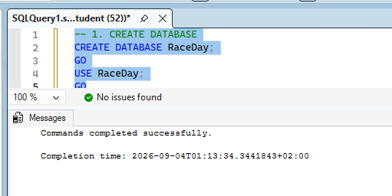

Create Tables
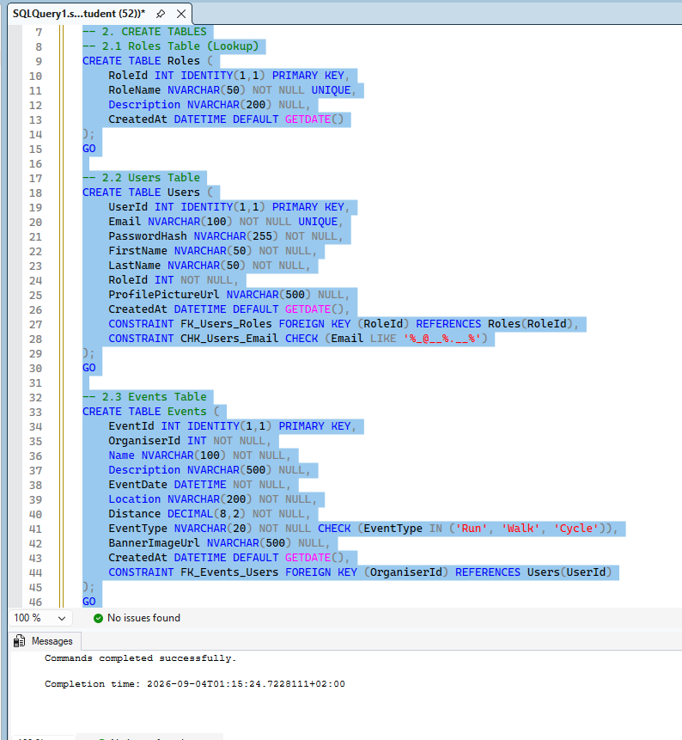

Insert Data
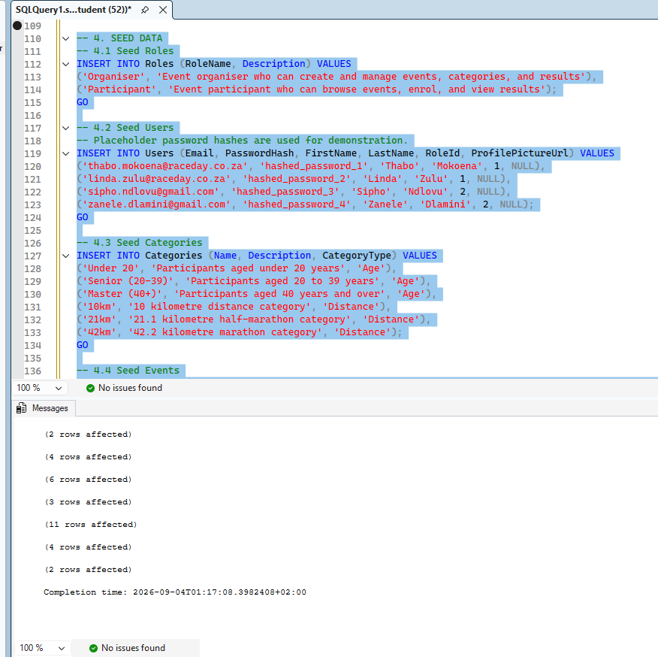

Verification Queries
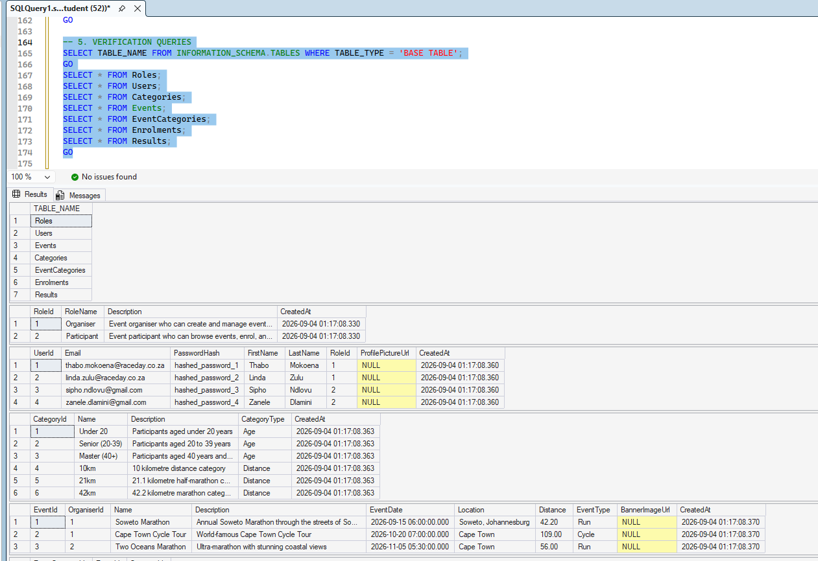

Section D — GitHub, CI/CD and Submission Evidence

The workflow should be stored in .github/workflows

on:
push:
branches: [ main, develop ]
pull_request:
branches: [ main ]

jobs:
validate-docs:
runs-on: ubuntu-latest
steps:
- uses: actions/checkout@v4

- name: Check docs folder exists
run: |
if [ ! -d "docs" ]; then
echo "Error: docs folder not found"
exit 1
fi

- name: Check ERD file exists
run: |
if [ ! -f "docs/ERD.png" ] && [ ! -f "docs/ERD.pdf" ]; then
echo "Error: ERD file not found"
exit 1
fi

- name: Check Endpoint Plan exists
run: |
if [ ! -f "docs/EndpointPlan.md" ] && [ ! -f "docs/EndpointPlan.pdf" ]; then
echo "Error: Endpoint Plan not found"
exit 1
fi

- name: Check SQL Script exists
run: |
if [ ! -f "docs/RaceDayDB.sql" ]; then
echo "Error: SQL script not found"
exit 1
fi

- name: Validate SQL script contains CREATE statements
run: |
if ! grep -q "CREATE TABLE" docs/RaceDayDB.sql; then
echo "Error: SQL script missing CREATE TABLE statements"
exit 1
fi

- name: Success
run: echo "All Part 1 validation checks passed!"

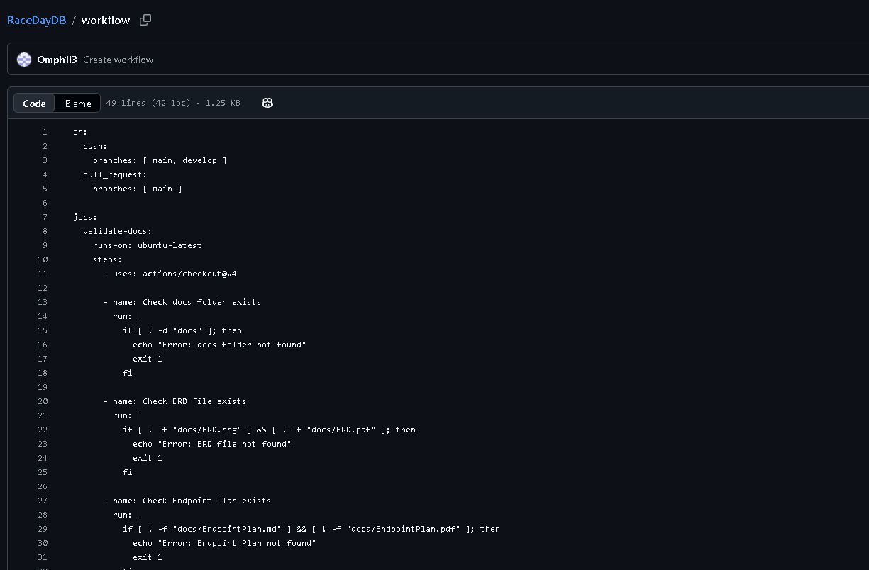Screenshots

. GitHub Commit Evidence
https://github.com/Omph1l3/RaceDayDB

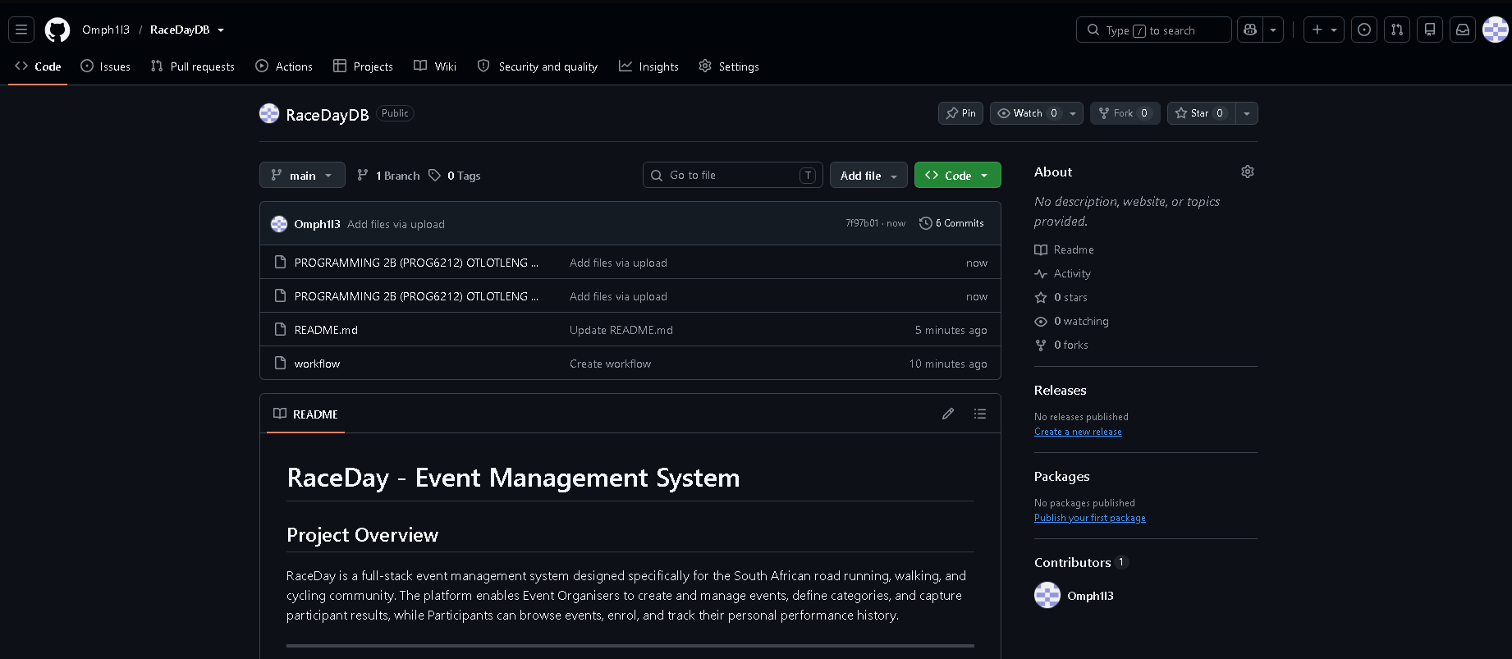
Readme
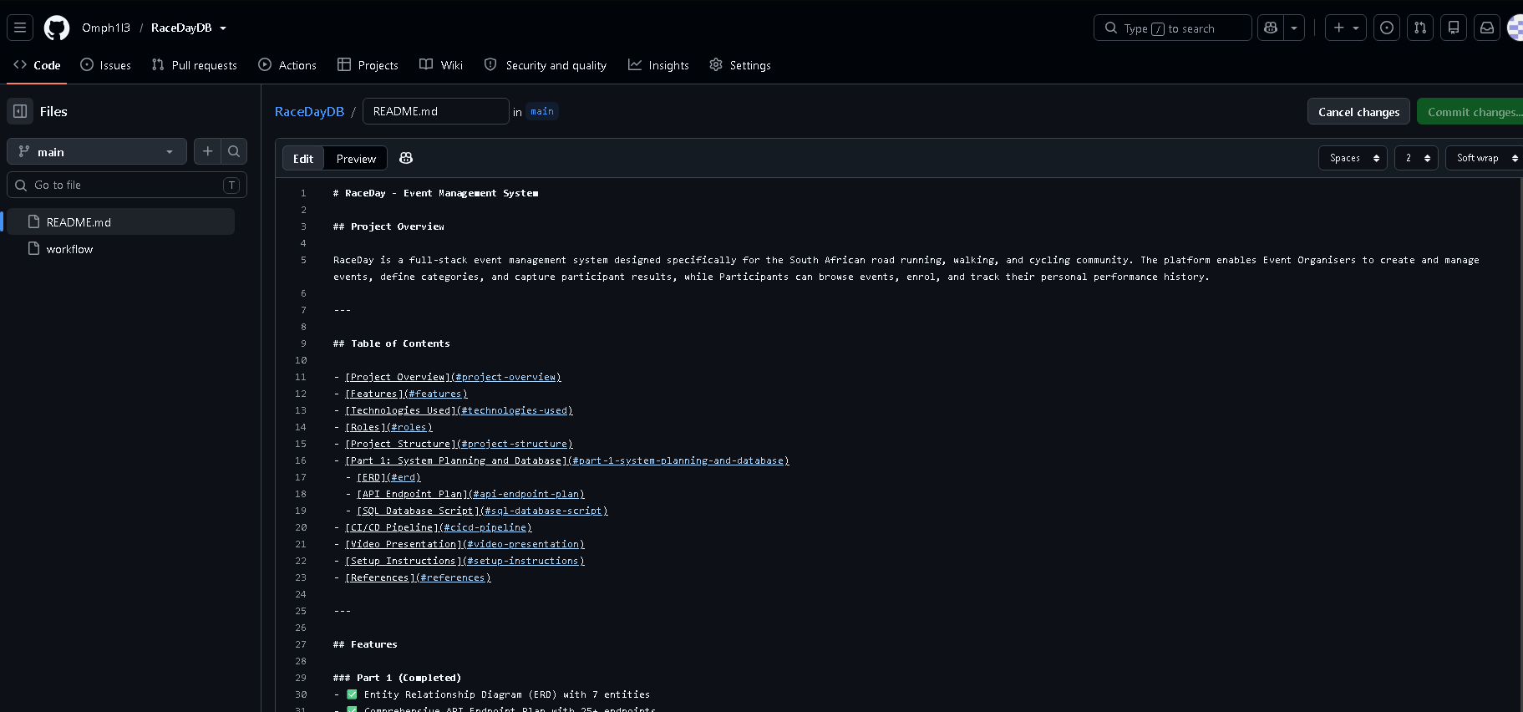Screenshot

Video
link

References
3Wschool (2025). W3Schools.Com. [online] W3schools.com. Available at: https://www.w3schools.com/sql/ [Accessed 28 Aug. 2026].
Bootstrap (2023). Get started with Bootstrap. [online] getbootstrap.com. Available at: https://getbootstrap.com/docs/5.3/getting-started/introduction/ [Accessed 28 Aug. 2026].
chcomley (2026a). Azure Boards documentation. [online] Microsoft Learn. Available at: https://learn.microsoft.com/en-us/azure/devops/boards/ [Accessed 28 Aug. 2026].
chcomley (2026b). Azure DevOps documentation. [online] Microsoft Learn. Available at: https://learn.microsoft.com/en-us/azure/devops/ [Accessed 28 Aug. 2026].
dimitri-furman (2024). Monitoring and performance tuning — Azure SQL Database & Azure SQL Managed Instance. [online] Microsoft Learn. Available at: https://learn.microsoft.com/en-us/azure/azure-sql/database/monitor-tune-overview [Accessed 28 Aug. 2026].
IBM (2024). Think topics | IBM. [online] IBM.com. Available at: https://www.ibm.com/think/topics/agile [Accessed 28 Aug. 2026].
pauljewellmsft (2023). Get started with Azure Blob Storage and .NET — Azure Storage. [online] Microsoft Learn. Available at: https://learn.microsoft.com/en-us/azure/storage/blobs/storage-blob-dotnet-get-started [Accessed 3 Sept. 2026].
scrumguides (2025). Home | Scrum Guides. [online] scrumguides.org. Available at: https://scrumguides.org/ [Accessed 28 Aug. 2026].

Part 2

The Program
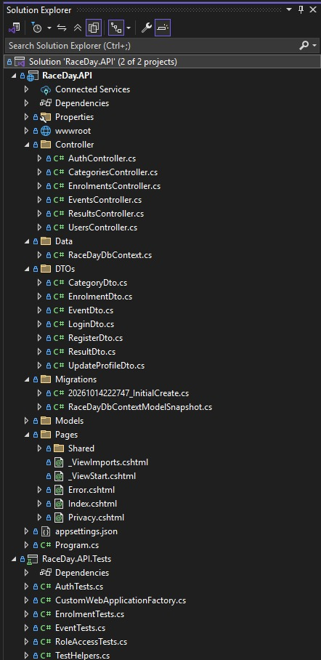

Unit Test

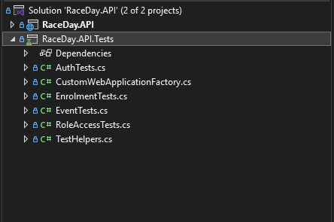

Program running

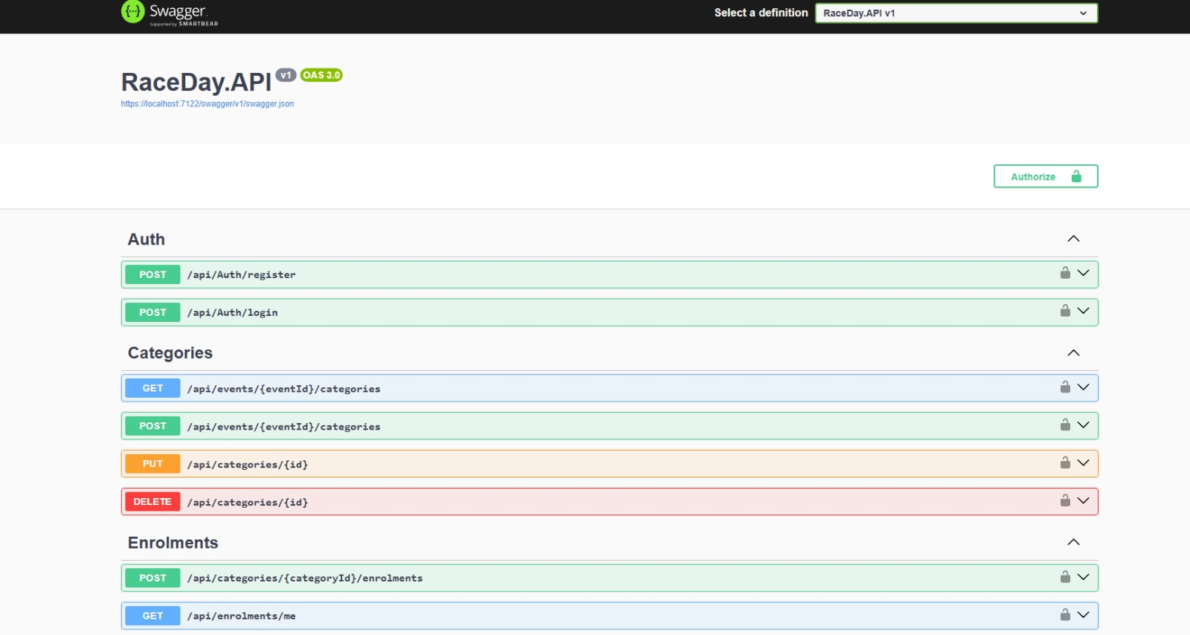

Git hub
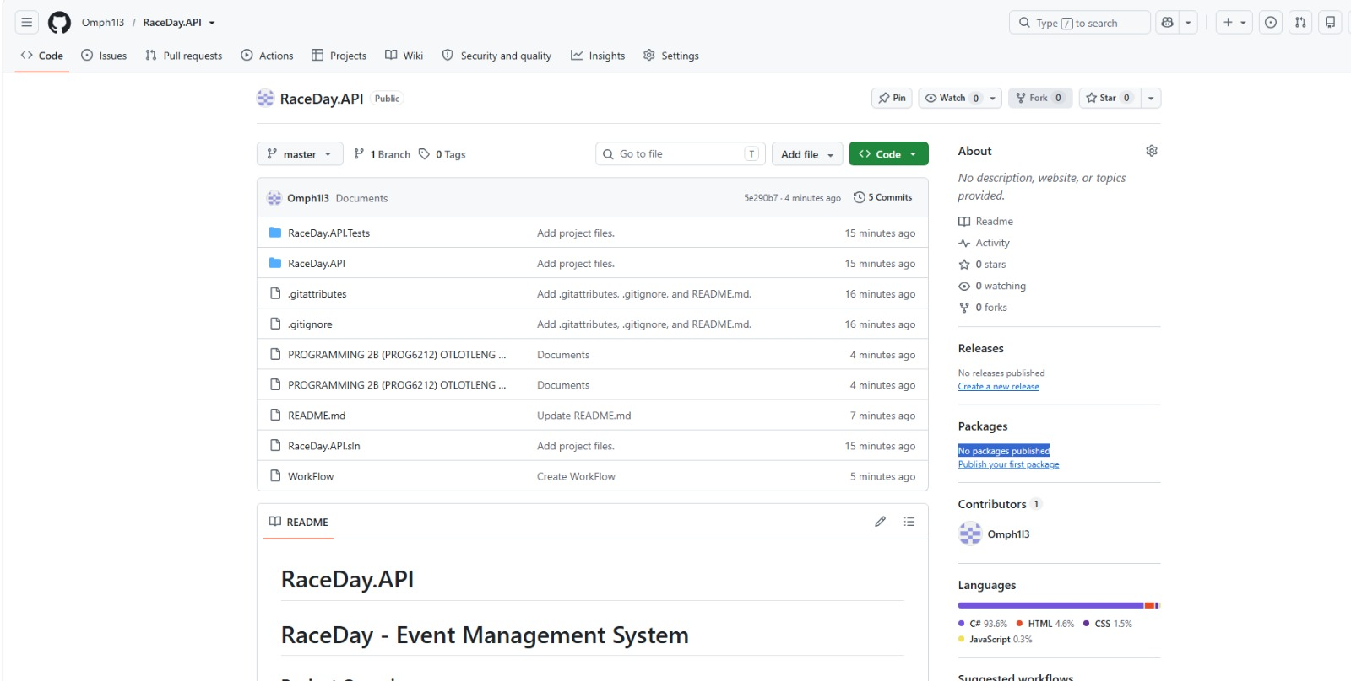

README.md
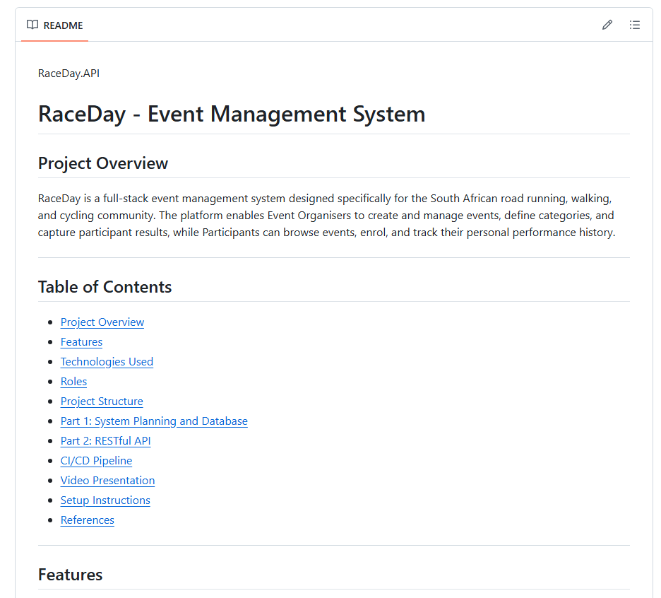

YouTube link

